Miles Shinsato

11/17/2024

Module 5.2 Assignment

CSD310-A339

One function that I want to highlight is UPPER.

This function is used to convert text to uppercase. This can be useful to standardize how text data is formatted.

An example of this would be this command:

SELECT UPPER(‘hello world’) as ‘Uppercase Text’;

It will return with the result displayed as it is in the screenshot below.

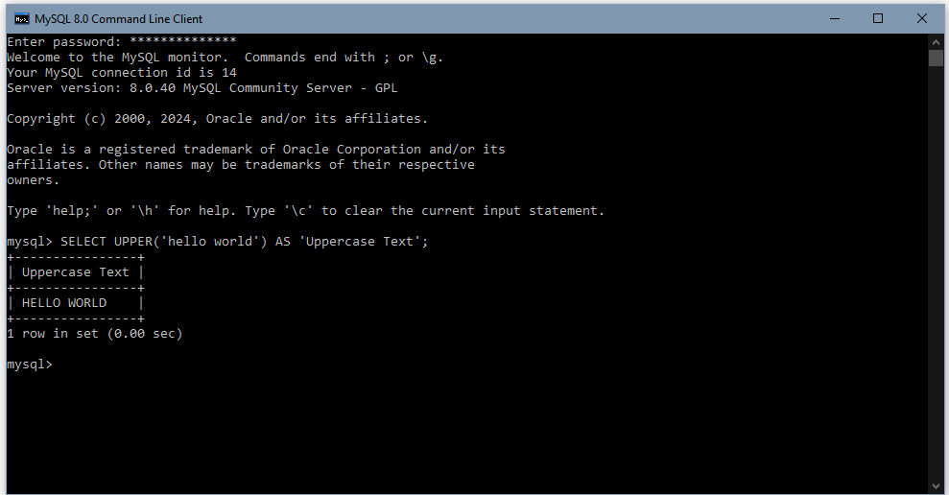

Another function that I want to highlight would be DATEDIFF.

This function is used to calculate the difference between two given dates in days. This can be useful in tracking time spans.

An example would be this command:

SELECT DATEDIFF('2024-12-22', '2024-11-17') AS 'Days Difference';

It will return with the result displayed as it is in the screenshot below.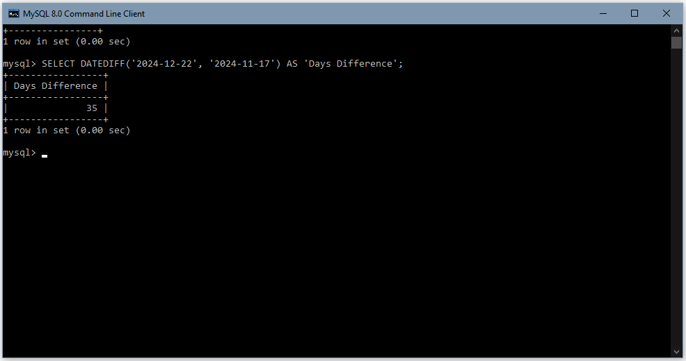

The last function that I want to highlight is CONCAT.

This function is used to combine two more strings into one. This could be great for something like combining first and last names of a customer lists or other text data.

An example would be this command:

SELECT CONCAT('Miles ', 'N. ' , 'Shinsato ') AS 'Name';

This will return with the result displayed as it is in the screenshot below.

**References:**

*W3Schools.com*. (n.d.). https://www.w3schools.com/sql/sql_ref_mysql.asp